**Pivot Table :-**

A pivot table is a data summarization tool in spreadsheet software, like Microsoft Excel or Google Sheets, used to organize and analyze large amounts of data. It allows users to reorganize and summarize selected columns and rows of data into a more manageable format, making it easier to identify patterns, trends, and relationships within the dataset. Users can dynamically restructure the pivot table by dragging and dropping fields to view the data from different perspectives.

Sure, here are the key points about pivot tables in easy language:

**1. Summarize Data:** Pivot tables help summarize large amounts of data into a more manageable format.

**2. Drag and Drop:** You can drag and drop fields to organize data by different categories like dates, products, or regions.

**3. Flexible Analysis:**  Easily switch between different views of your data without altering the original dataset.

**4. Aggregation :** Perform calculations like sums, averages, counts, etc., on your data within the pivot table.

**5. Dynamic Updating:** When your data changes, pivot tables can automatically update to reflect those changes.

**6. Charts and Graphs:** Pivot tables can be used to create charts and graphs for better visualization of data trends.

**7. Easy Customization:** Customize the layout, formatting, and appearance of your pivot table to suit your needs.

**8. Data Exploration:** Quickly explore your data by filtering, sorting, and grouping within the pivot table interface.

In simple terms, pivot tables help you organize and analyze your data easily without needing to know complex formulas or coding.

Now Applying Slicer Filter on data :-

* Page 1

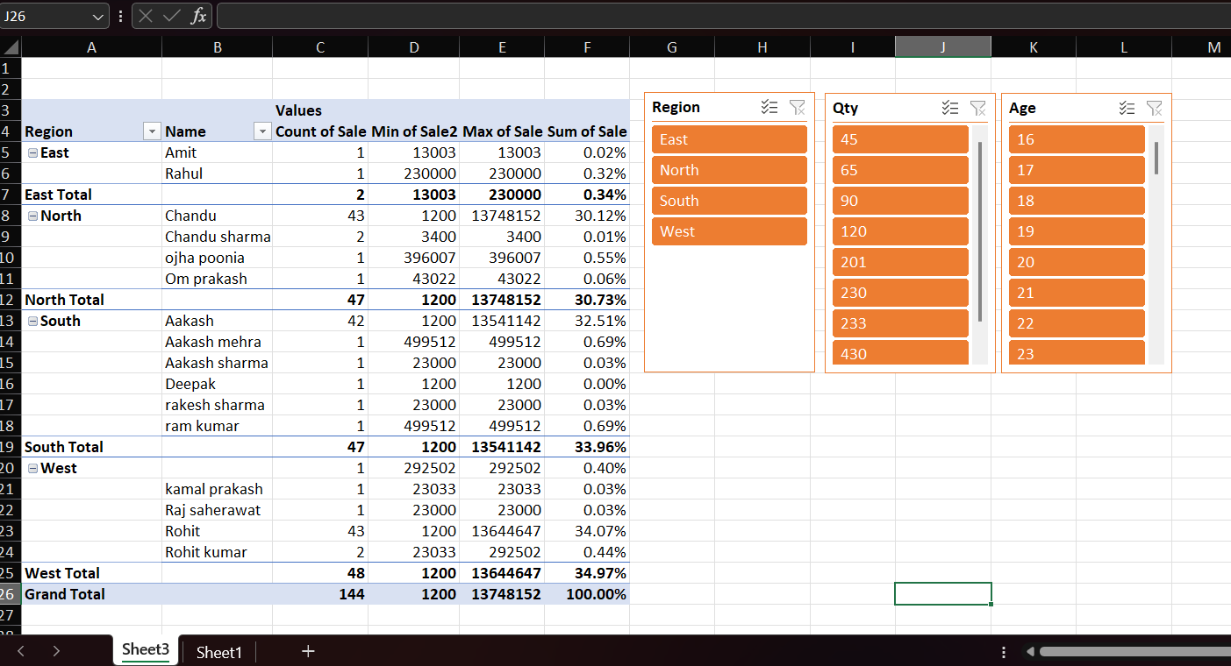

* Page 2

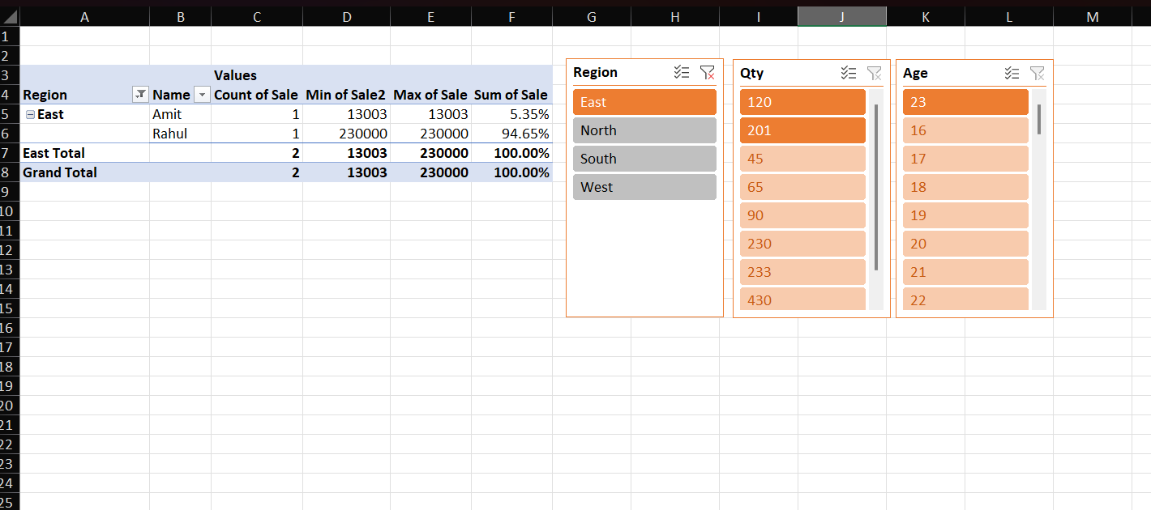

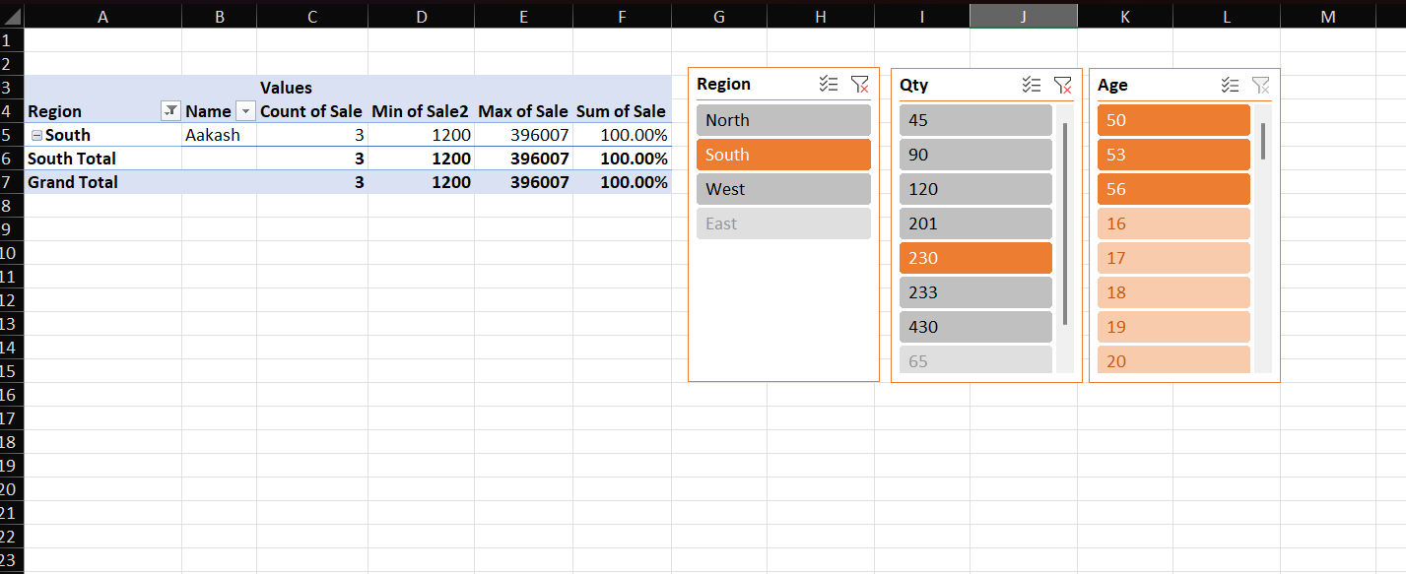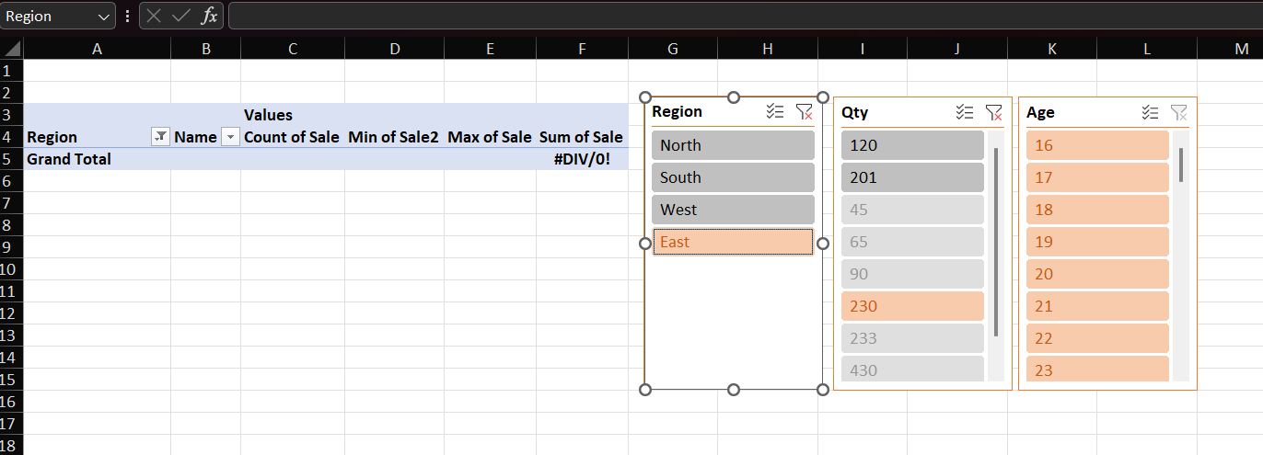

**Inserting Slicer filter on time line :-**

Page 1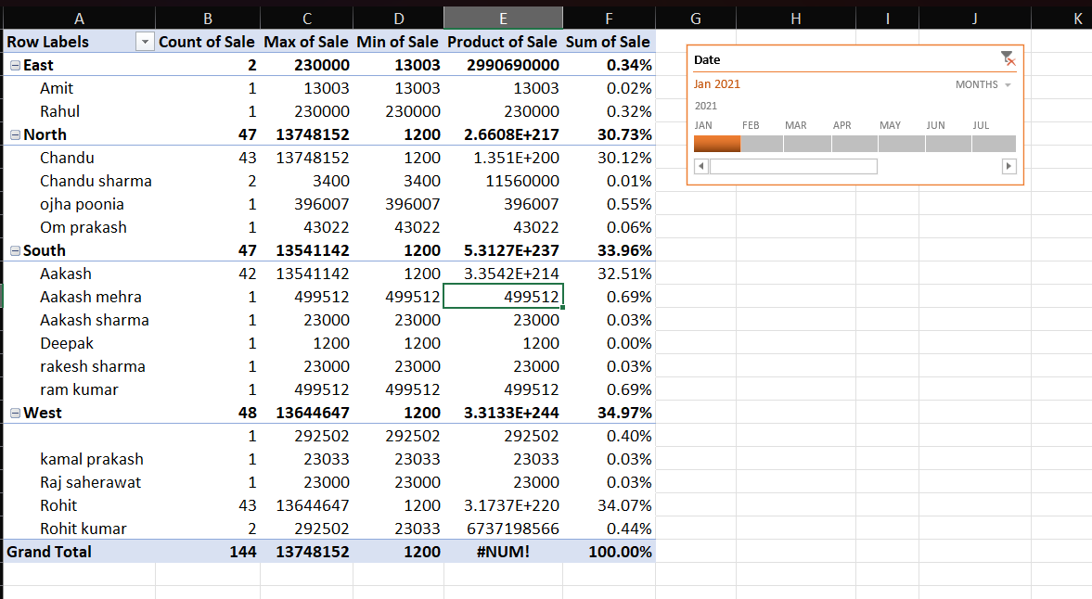

* Page 2